Servlet API->

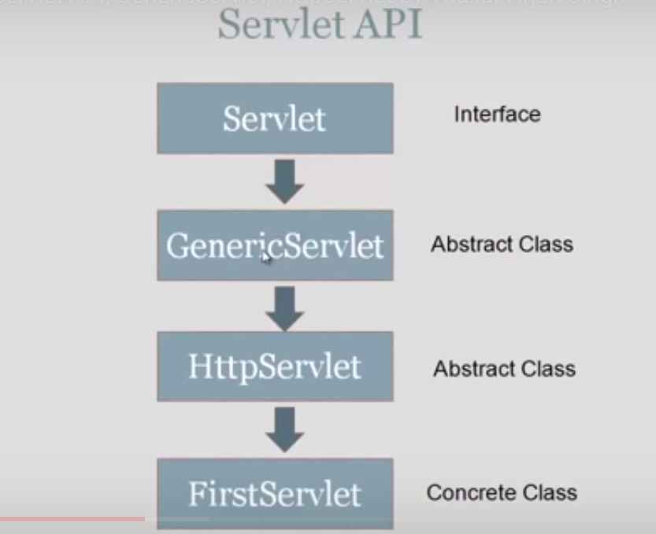

*The javax.servlet and javax.servlet.http packages represent interfaces and classes for servlet api.

*The **javax.servlet** package contains many interfaces and classes that are used by the servlet or web container. These are not specific to any protocol.

The **javax.servlet.http** package contains interfaces and classes that are responsible for http requests only.

### **Interfaces in javax.servlet package->**

There are many interfaces in javax.servlet package. They are as follows:

1. Servlet
2. ServletRequest
3. ServletResponse
4. RequestDispatcher
5. ServletConfig
6. ServletContext
7. SingleThreadModel
8. Filter
9. FilterConfig
10. FilterChain
11. ServletRequestListener
12. ServletRequestAttributeListener
13. ServletContextListener
14. ServletContextAttributeListener

### **Classes in javax.servlet package->**

There are many classes in javax.servlet package. They are as follows:

1. GenericServlet
2. ServletInputStream
3. ServletOutputStream
4. ServletRequestWrapper
5. ServletResponseWrapper
6. ServletRequestEvent
7. ServletContextEvent
8. ServletRequestAttributeEvent
9. ServletContextAttributeEvent
10. ServletException
11. UnavailableException

